ST. XAVIER’S COLLEGE

(Affiliated to Tribhuvan University)

Maitighar, Kathmandu



**Computer Network Lab Assignment #2**

**SUBMITTED BY:**

Pradeep Dahal

017BSCIT029

2nd Year/4th Sem

|  |  |
| --- | --- |
| **Mr. Sanjay Kumar Yadav**  **(Lecturer)** |  |
| **Department of Computer Science** | |

**OBJECTIVE: INTRODUCTION TO PACKET TRACER, CREATING OF A LAN AND CONNECTIVITY TEST IN THE LAN.**

**REQUIREMENTS:**

1. CISCO Packet Tracer
2. End Devices
3. Switches
4. Copper Straight-Through Cables
5. Copper Cross-Over Cables

**THEORY:**

Packet Tracer is a powerful network simulator that can be utilized in training for network certification like and learning by allowing students to create networks with an almost unlimited number of devices and to experience troubleshooting without having to buy real Cisco routers or switches. The tool is created by Cisco Systems. The purpose of Packet Tracer is to offer students a tool to learn the principles of networking. Packet tracer allows us to create network by just dragging and dropping devices and connection to specific port of the devices so that necessary configuration shall be performed on each device and test as per the requirement. Group of computers are connected to switch and are assigned ip addresses of same network in which each computer in the network are directly reachable. These interconnected group of computers and its infrastructure is called Local Area Network (LAN).

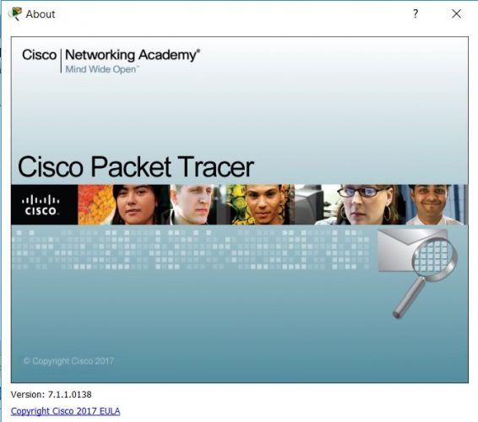

**Definition**: Packet Tracer is a protocol simulator developed by Dennis Frezzo and his team at Cisco Systems. Packet Tracer (PT) is a powerful and dynamic tool that displays the various protocols used in networking, in either Real Time or Simulation mode. This includes layer 2 protocols such as Ethernet and PPP, layer 3 protocols such as IP, ICMP, and ARP, and layer 4 protocols such as TCP and UDP. Routing protocols can also be traced.

**NETWORK TOPOLOGY:**

Network topology describe the physical and logical appearance and interconnection between arrangement of computers, cables and other components in a data communication network and how it can be used for taking a packet from one device and sending it through the network to another device on a different network. A network topology is the physical layout of computers, cables, and other components on a network. There are several different network topologies, and a network may be built using multiple topologies. The different types of network topologies are: Bus topology, Star topology, Mesh topology, Ring topology, Hybrid topology etc.

**IPv4 ADDRESSING AND SUBNETTING:**

An IP address is a numeric identifier assigned to each machine on an IP network. It designates the specific location of a device on the network. IP addressing was designed to allow hosts on one network to communicate with hosts on different networks regardless of the type of LAN the hosts are participating in.

**Classes of Addresses:**

There are five classes of IP addresses and they are shown in the Table

A screenshot of a cell phone

Description generated with very high confidence

IP addresses can be dynamically configured using DHCP or they can be statically configured by inputting it manually on the device.

**Subnet Mask:**

For the subnet scheme to work, every host (machine) on the network must know which part of the host address will be used as the subnet address. This is accomplished by assigning subnet mask to each machine. A subnet mask is a 32-bit value that allows the recipient of an IP packet to distinguish the network ID portion of the IP address from the host ID portion of the IP address. Table below shows the default subnet masks for all classes of network.

A screenshot of a cell phone

Description generated with very high confidence

**PROCEDURE:**

Step 1: Start Packet Tracer

Step 2: Choosing Devices and Connections

We will begin building our network topology by selecting devices and the media in which to connect them. Several types of devices and network connections can be used. For this lab we will keep it simple by using End Devices, Switches, and Connections.

Single click on each group of devices and connections to display the various choices.

A screenshot of a social media post

Description generated with very high confidenceA screenshot of a cell phone

Description generated with very high confidenceA screenshot of a cell phone

Description generated with very high confidence

Step 3: Building the Topology – Adding Hosts

A screenshot of a video game

Description generated with high confidenceA screenshot of a video game

Description generated with high confidence

To connect like-devices, like switch to switch, we will use a copper Cross-over cable.

To connect, unlike-devices, like switch to PC, we will use a copper straight through cable.

Perform the following steps to connect PC0 to Switch0:

1. Click once on PC0

2. Choose FastEthernet

3. Drag the cursor to Switch0

4. Click once on Switch0 and choose FastEthernet0/1

5. Notice the green link lights on PC2 Ethernet NIC and amber light Switch0 FastEthernet0/1 port. The switch port is temporarily not forwarding frames, while it goes through the stages for the Spanning Tree Protocol (STP) process.

6. After a about 30 seconds the amber light will change to green indicating that the port has entered the forwarding stage. Frames can now forward out the switch port.

Step 5: Configuring IP Addresses and Subnet Masks on the Hosts

Before we can communicate between the hosts we need to configure IP Addresses and Subnet Masks on the devices.

A screenshot of a cell phone

Description generated with very high confidence

Step 6: Building the LAN

Now we join the two topologies, connecting the two switches in both topologies through cross over cable.

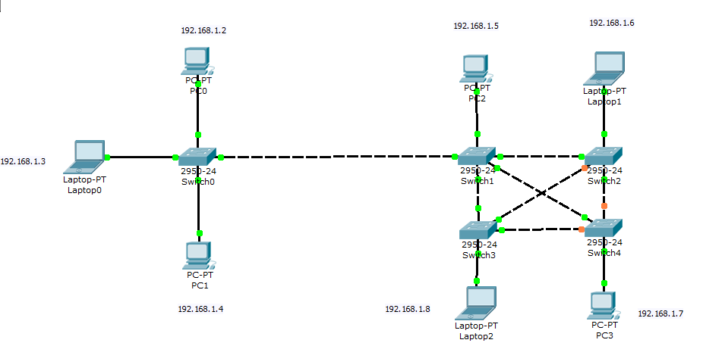

Step 7: Verifying Connectivity in Simulation Mode

A close up of a device

Description generated with high confidence

Be sure you are in Simulation mode.

Deselect all filters (All/None) and select only ICMP

A screenshot of a cell phone

Description generated with very high confidence

Select the Add Simple PDU tool used to ping devices. A close up of a logo

Description generated with high confidence

Click once on LAPTOP0, then once on PC3.

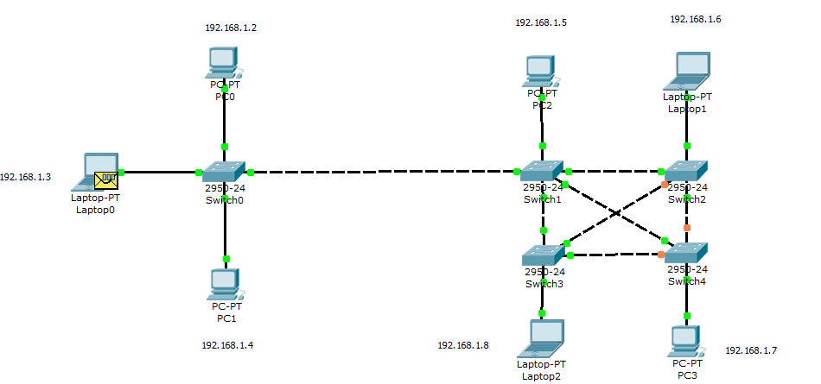

A picture containing sky

Description generated with high confidence

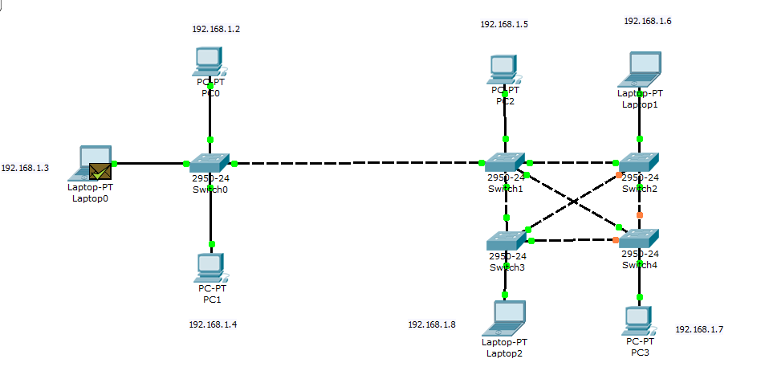

Clicking Auto Capture / Play. You should see the ICMP messages move between the hosts, hub and switch. Click on Clear Event List if you do not want to look at the events or click Preview Previous Events if you do.

Step 8: Saving the Topology

**CONCLUSION:**

In this lab work, a Local Area Network (LAN) have been implemented with some important concepts like DHCP, DNS, Email, VLANs in a single network using Cisco Packet Tracer. VLANs have been used to logically group clients on the network, and with the aid of a router and switch configurations, data packets routed from one device to another.